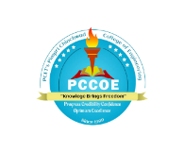 | Pimpri Chinchwad Education Trust's  Pimpri Chinchwad College of Engineering, Pune  An Autonomous Institute  (Affiliated to Savitribai Phule Pune University) |   IIC ID: IC201810343  
World Entrepreneurs Day 2025
(21st September 2025)
Attendance Sheet Participants
Date: 21/09/2025
Sr. No. | Name | Sign
1
2
3
4
5
6
7
8
9
10
11
12
13
14
15
16
17
18
19
20
21
22
23
24
25
26
27
28
29
30
31
32
33
34
35
36
37
38
39
40
41
42
43
44
45
46
47
48
49
50
51
52
53
54
55
56
57
58
59
60

